*Applied random forest w/ raw datam*

*Now*

*Would*

* **criterion=none:looks♋️♋️♋️**

CMM : 0.8374459475542508

AUC woo: 0.8871973393634043

**criterion=”gini”:**

CMM: 0.8321894711786408

AUC: 0.8833789555811217

**criterion=”entropy”:**

CMM: 0.7989050660530805

AUC: 0.8863377897673927

*Applied random forest w/ normalized data (/255)*

**criterion=none:**

CMM: 0.8546363925055572

AUC: 0.8981257277442576

**criterion=”gini”:**

CMM: 0.851281271084417

AUC: 0.8911084946222334

CMM: 0.8751933986591027r

AUC: 0.8873328837227754

n_estimators=240, max_depth = 15, min_samples_split = 3

CMM: 1071

AUC: 0.9101076420571006

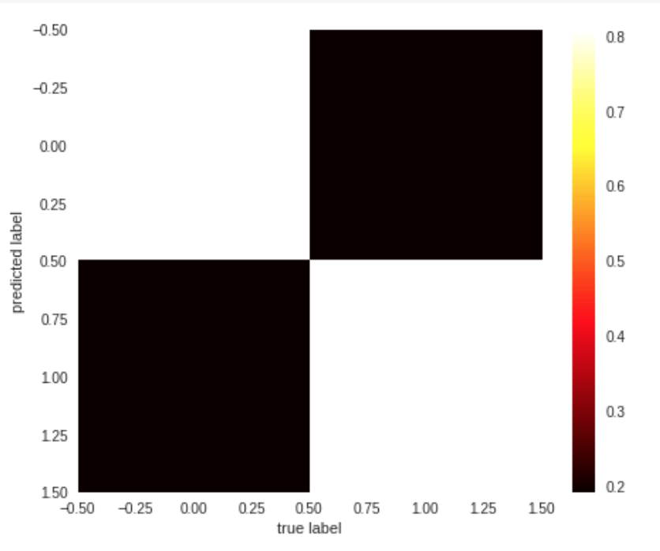

Random Forest Classifier for MultiClass

n_estimators=243, max_depth = 13, min_samples_split=3

CMM = 113

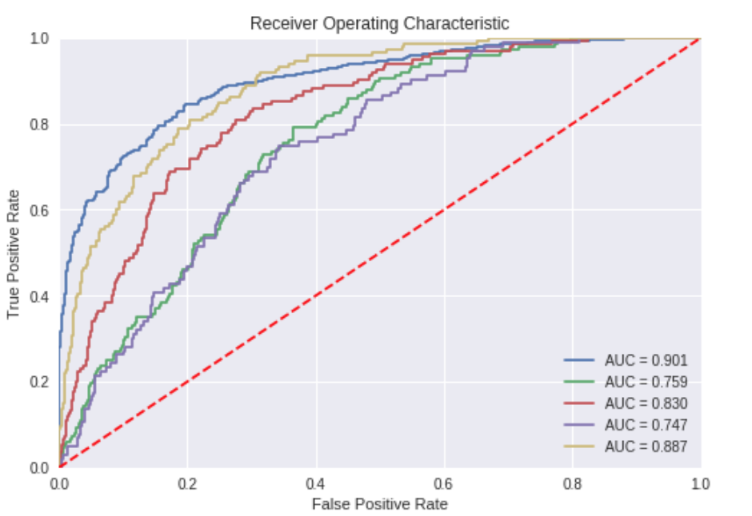

n_estimators=243, max_depth = 15, min_samples_split=3

CMM = 133

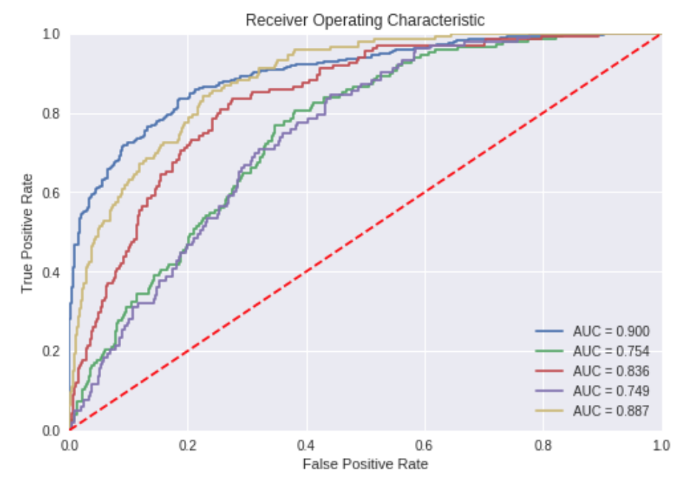

n_estimators=247, max_depth = 15, min_samples_split=4

CMM = 137

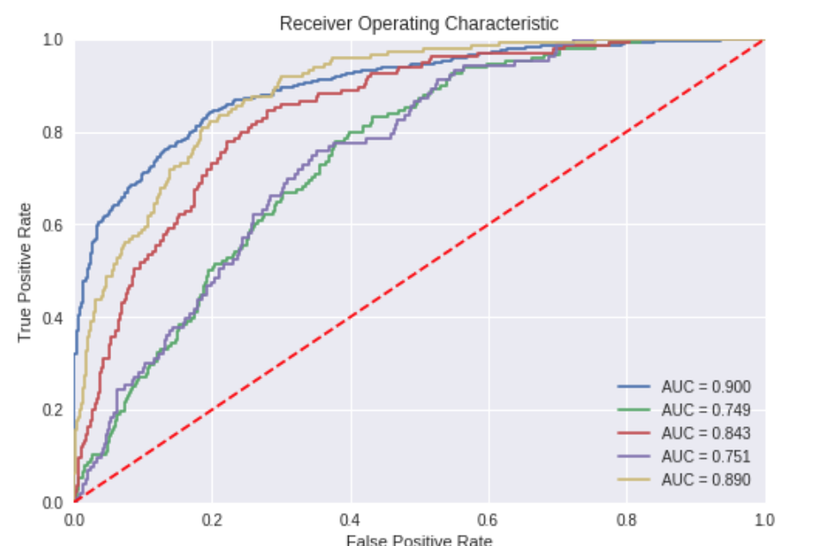

n_estimators=250, max_depth = 15, min_samples_split=4